HandsOn Experiment G1

## Basics of PWM [**Pulse Width Modulation**]:

PWM pins are used to convert digital waves into analogue waves.

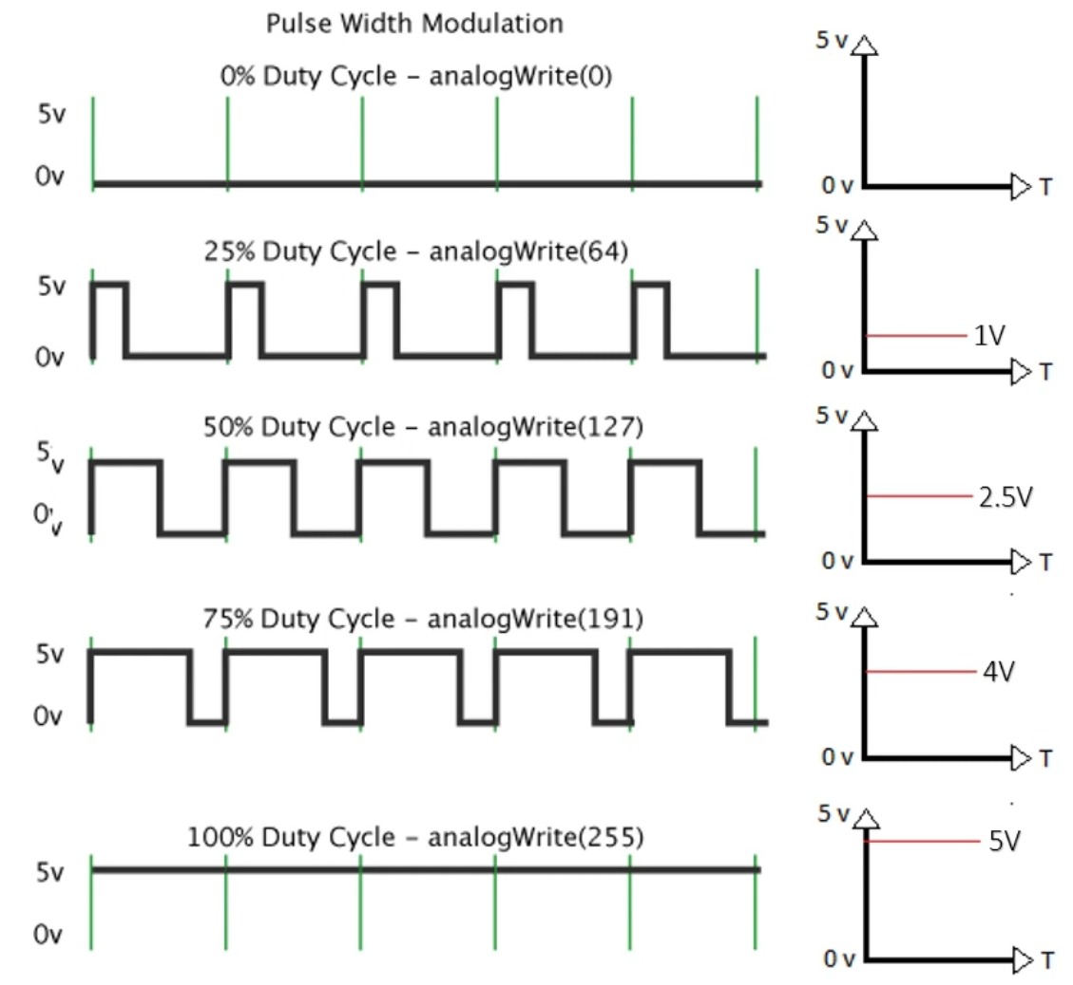Here, our objective is to generate voltages in the digital pin **within 5v( HIGH )** and **0v( LOW )**.

**Duty Cycle:** *#analogeWrite*

0% = aw( 0 )

25% = aw( 64 )

50% = aw( 127 )

75% = aw( 191 )

100% = aw( 255 )

**Code:** *#analogeWrite*

#define light 11

void setup() {

  pinMode(light, OUTPUT);

}

void loop() {

  for (int i = 0; i <= 255; i++) {

    analogWrite(light, i);

    delay(1000);

  }

  for (int j = 255; j >= 0; j--) {

    analogWrite(light, j);

    delay(500);

  }

}

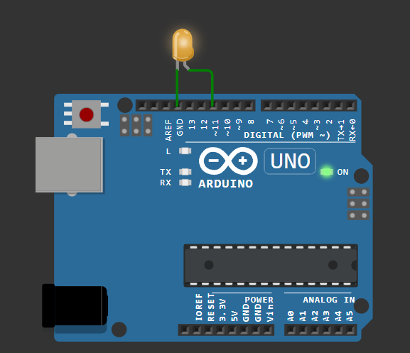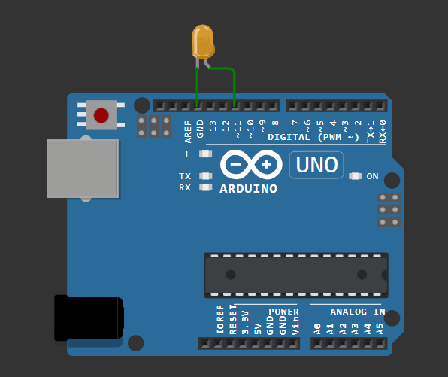

Wokwi#HO1: <https://wokwi.com/projects/409801191342923777>

## RGB [ Common Cathode ]: PWM

const int nColors = 3; // define the number of colors

const int red = 0; // position in the colorPin array for the red pin

const int grn = 1; // position in the colorPin array for the green pin

const int blu = 2; // position in the colorPin array for the blue pin

// Define pin numbers for the RGB LED

const int redPin = 9;

const int grnPin = 10;

const int bluPin = 11;

// Declare the colorPin array globally

const int colorPin[nColors] = {redPin, grnPin, bluPin};

void coloron(int color, int intensity) {

switch (color) {

case red:

      analogWrite(colorPin[red], intensity);

      break;

    case grn:

      analogWrite(colorPin[grn], intensity);

      break;

    case blu:

      analogWrite(colorPin[blu], intensity);

      break;

  }

}

void coloroff(int color){

  analogWrite(colorPin[color], 0);

}

void allColorsOff() {

  for (int color = 0; color < nColors; color++) {

    coloroff(color);

  }

}

void setup() {

  pinMode(redPin, OUTPUT);

  pinMode(grnPin, OUTPUT);

  pinMode(bluPin, OUTPUT);

}

void loop() {

  // Start turning on and off lights

  for (int color = 0; color < nColors; color++) {

    for (int i = 0; i < 256; i++) { // slowly increase the color

      coloron(color, i);

      delay(5);

    }

    for (int i = 255; i > 0; i--) { // slowly decrease the color

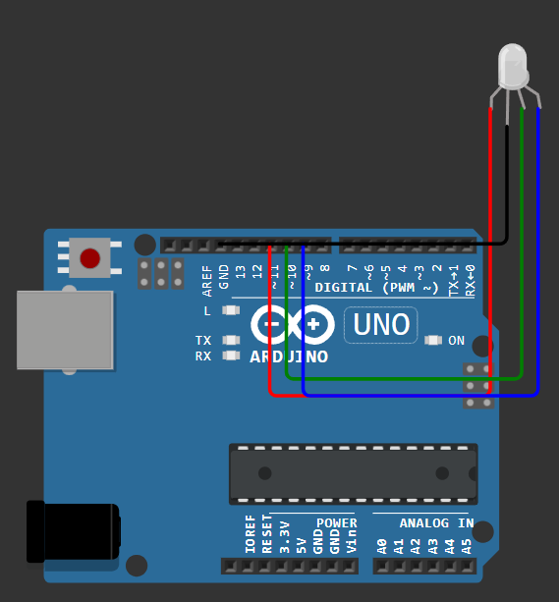      coloron(color, i);

      delay(5);

    }

    coloroff(color);

  }

  delay(500);

  // Generate cyan light

  coloron(red, 0);

  coloron(grn, 255);

  coloron(blu, 255);

  delay(2000); // Display cyan for 2 seconds

  // Turn off all colors

  allColorsOff();

}

Wokwi#HO2: <https://wokwi.com/projects/409805684061827073>